Name:-
Talha Kayani

Roll No :-
2530366

Dept.:-
BS CYS(B)

Course:-
OOP LAB

Assignment Q1:
The program allows users to add and manage student and graduate student records through a menu-driven interface. It supports operations such as adding student data, displaying all students, and viewing graduate student details.
Key OOP concepts used in this project include:
- Inheritance
- Encapsulation
- Constructors
- Function overloading (basic usage)
- Arrays of objects

Output:
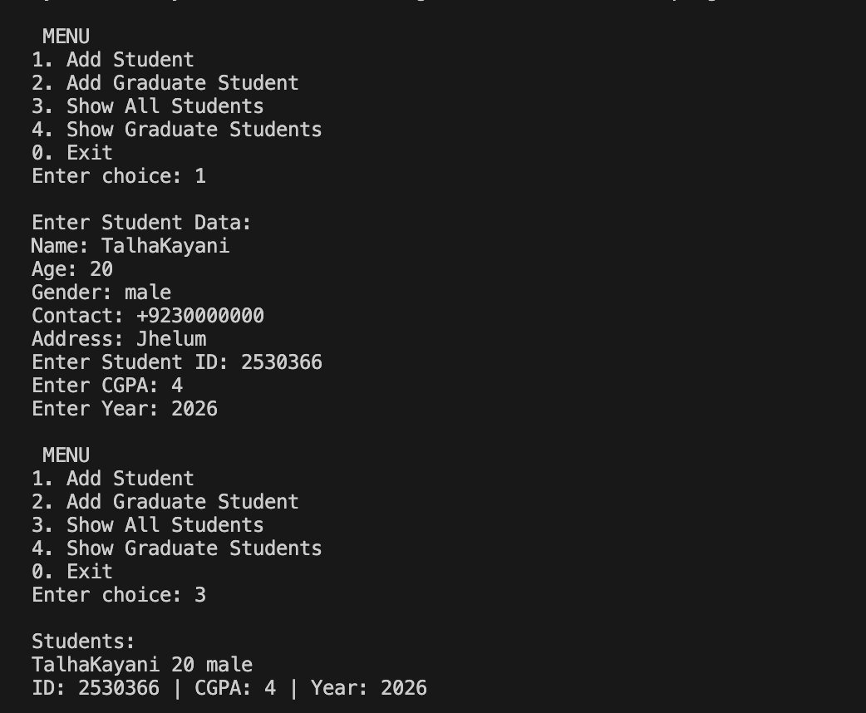

Assignment Q2:
This project implements a C++ inheritance-based system with a Vehicle base class and Car and Bike derived classes. It demonstrates constructor chaining, encapsulation, and function handling to manage and display vehicle details.
Output:
